The Ridiculous Case of Advocate Murugan
President:
Justice (Retd.) H. Suresh
Vice- Presidents:
Sudha Bharadwaj
M. Venkanna
General Secretary:
Surendra Gadling
Joint Secretaries:
Ankit Grewal
Suresh Kumar
Treasurer:
Arun Ferreira
Executive Committee:
A. Dhashrath
Aarti (Chandigarh)
Amarnath Pandey (Chhattisgarh)
Arjun Sheoran (Chandigarh)
Basant Dhahake (MP)
Gurunathan (TN)
K. S. Chalam (AP)
Monica Sakrani (Maharashtra)
Pankaj Tyagi (Haryana)
R. Mahadevan (Telangana)
Shiv Prasad Singh (Jharkhand)
Shyam Sinha (Bihar)
P. Srinivas (AP)
Suresh Tekade (Maharashtra)
B. S. Upadhaya (Bihar)
Vinayak Kakade (Maharashtra)

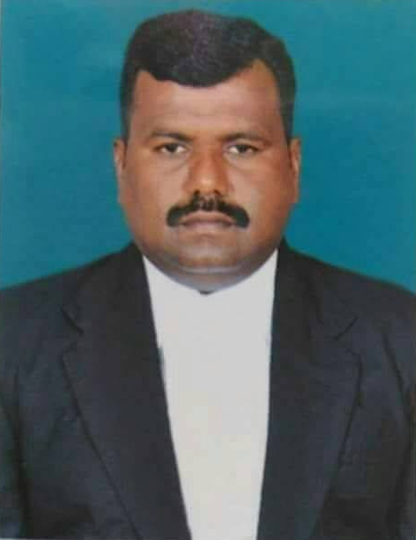
A. Murrugan, a young lawyer practicing at the Madurai Bench of the Madras High Court was arrested from his residence on 8th January 2017. The police had gone to his house in the early morning 4 o’clock, and after arresting him seized his case papers, files, preparations for final arguments for some cases and books, Homeopathy medicines & a medical book, all easily available in the market. Ayyanan Murugan is also the Secretary of the Centre for Protection of Civil Liberties (CPCL), Tamilnadu. What makes his case rather surprising is that this Human Rights Lawyer was arrested in the same criminal trial wherein he was defending two accused and has been incarcerated since then.
It was based on these preliminary facts that the Indian Association of People’s Lawyers (IAPL) decided to send a team of lawyers from across the country to look into the absurdity of his case. D. Sureshkumar (Hyderabad), Arun Ferreira (Mumbai), Jagdish Meshram (Gadchiroli) and Gurunathan (Tamilnadu) from IAPL arrived in Madurai on 3rd August 2017. The team was able to meet Murugan who was in Trichy prison and collect the chargesheets filed against him. The team also met his wife, who too is a lawyer, some of his colleagues in court and the two counsels who defending him in applications before the High Court namely Adv. Jayaramachandran and Adv. Lajapathi Roy of Madurai.
Murugan had been defending one Mrs. Kala and Mrs. Chandra, both residents of Salem, Tamilnadu. They had been arrested in a case, registered in Karur by ‘Q’ Branch CID via Crime No. 1 of 2016 under sections 18-A, 18-B, 20 and 38 of the Unlawful Activities (Prevention) Act and Section 120B of the Indian Penal Code. Briefly, they were charged for allegedly organizing a terrorist camp (S. 18A), for recruiting persons for any terrorist act (S. 18B), for membership of a terrorist gang or organization (S. 20 & S.38) and for criminal conspiracy (S. 120B) i.e. all charges were due to their alleged membership of CPI (Maoist), an organization banned under the schedule of the UA(P)A. Both the accused had been arrested on 21st July 2016 and Murugan had been defending them in the Courts ever since.
Surprisingly, as part of the investigations in this case, the DySP, ‘Q’ Branch CID submitted an application before the District and Sessions Judge, Karur for arraigning Muruggan into the same case. A copy of this application was examined by the IAPL team members and grounds for which Murugan was sought to be arraigned are briefly mentioned below:
- It was alleged that the accused Mrs. Kala was in constant phone conversation with her advocate Murugan prior to her arrest. The mobile she allegedly used to talk to Murugan with, had been seized by the ‘Q’ Branch. It ought to be noted that communication between an advocate and her client is deemed as a privileged communication under the Indian Evidence Act, 1972 (S. 129). These laws strictly hold that such communication cannot be used as evidence during a trial.
- So-called confessional statements of both the accused Mrs. Kala and Mrs. Chandra mentioning the role of Advocate Murugan in the functioning of the CPI (Maoist). These statements have no evidentiary value during a trial.
- Statements of two witnesses. One, alleging that she came to know that the accused Mrs. Kala had stayed at Advocate Murugan’s house and office with another and discussed ‘future activities of the organisation and mobilization of funds for the CP (Maoist)’. The other alleged that she came to know that Advocate Murugan had ‘exerted pressure’ on an accused in another case to jump bail and abscond. Once again both these statements being hearsay evidence have no evidentiary value during a trial.
- Finally, the application also alleged that the younger brother of Advocate Murugan is a long time absconding accused in two cases registered in 2007 and 2008.
It was based on this abovementioned application by the ‘Q’ Branch CID that Advocate Murugan came to be arrested and warrants were issued for the search of his premises. The search resulted in the seizure of Homeopathy medicines, that the prosecution alleges are for the CPI(Maoist). After obtaining the sanction of the State government for prosecution under UA(P)A, the ‘Q’ Branch CID filed their chargesheet against three accused including Murugan on 16th January 2017.
Based on these bizarre charges with absolutely no evidentiary value, Muruggan approached the Madurai Bench of the Madras High Court for Bail. However though arguments from both sides have been concluded on 11th May 2017, the verdict is still to be delivered.
Meanwhile, faced with the possibility that Murugan may be released on bail, the prosecution has taken custody of Murugan in another UA(P)A case i.e. Dharmapuri ‘Q’ Branch CID Crime No. 1 of 2017 u/s 13(1)(b), 18, 19, 20, 38 of UA(P)A and S. 120B IPC (FIR dated 1st January 2017). The charges are almost similar to the previous cases and here Murugan was taken on a production warrant from the Trichy prison and arraigned as the fifth accused in this case. The chargesheet in this case against Murugan was filed on 23rd June 2017. On perusal of the chargesheet, it was found that the prosecution, ‘Q’ Branch CID has sought to put forth some additional evidence for Murugan’s so-called unlawful activities. They are briefly mentioned as below:
- That, Advocate Murugan handed over a portable DVD player, tape-recorder, a Modem and some pamphlets and booklets of people’s organizations (functioning in tamilnadu, but alleged by the State as front organsisations of the banned CPI-Maoist) to one of the accused on 7th August 2016 and some money, cell phone and a dhoti and shirt to another accused. Both these charges are based on the so-called confessional statements of the accused which have no evidentiary value during a trial.
Advocate Murugan has to still file for bail in this case.
Conclusions
It is preposterous to even consider that any serious prosecution can succeed considering the so-called evidence filed against Murugan. In fact, the very intention of the State to prosecute Murugan has to be questioned. Why was Murugan arraigned in this case in the first place? Or why was the second case put on him only when bail arguments were completed in the first case? From the above facts, can we not conclude that the State desires to incarcerate Murugan regardless whether they have any material for prosecution. It seems to be a clear case wherein the State has identified a lawyer with the cause of his/her client- a practice regularly seen in so-called terrorist cases and trials under special anti terror laws. IAPL had observed in an earlier fact finding to Chhattisgarh how another Advocate Rekha Praganiya was was shown as absconding in an ongoing criminal case in which she herself had been representing the accused and was thereafter arrested.
Special ant-terror laws with broad and vague definitions of conspiracy, association and culpability often help the State to do so. In the case of Murugan, the State has sought to portray his communication and association with his clients as proof for applying charges under the UA(P)A. This is in violation to the Basic Principles of the Role of Lawyers, 1990 which clearly states that “Lawyers shall not be identified with their clients or their clients' causes as a result of discharging their functions” (Principle 18). By hindering Murugan to fearlessly practice his profession and defend his client, the State has also violated Article 19(1)(g) of the Constitution, a fundamental right, that guarantees a person the right to practice any profession.
It is with these conclusions that IAPL demands:
- RELEASE Adv A. Murugan immediately and unconditionally.
- STOP the branding of lawyers and their identifying them with the causes of their clients.
- STOP terrorizing the people in the name of “national security”.
- REPEAL the draconian Unlawful Activities (Prevention) Act

Date: 17th August 2017

